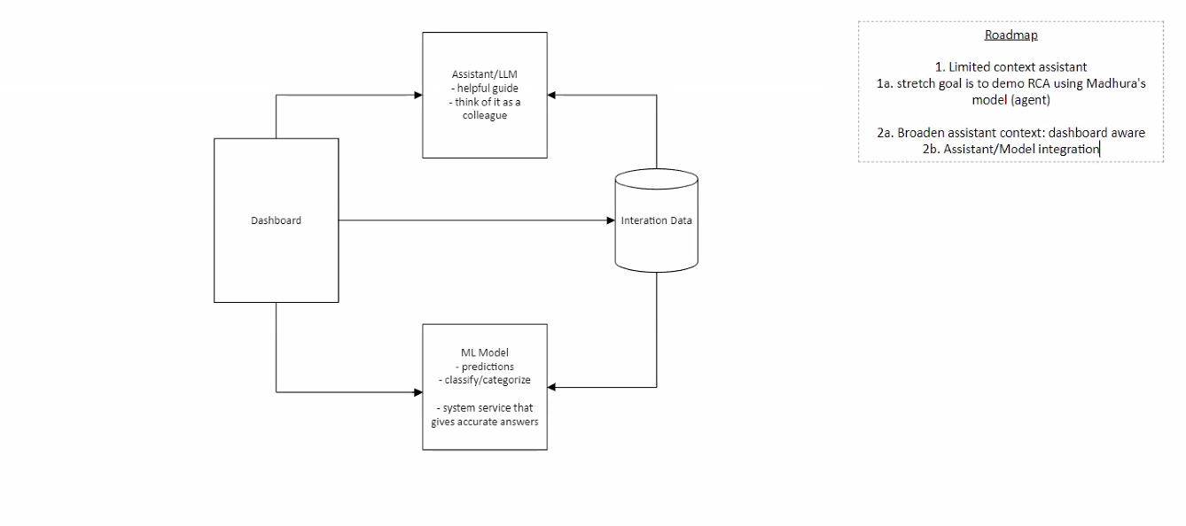

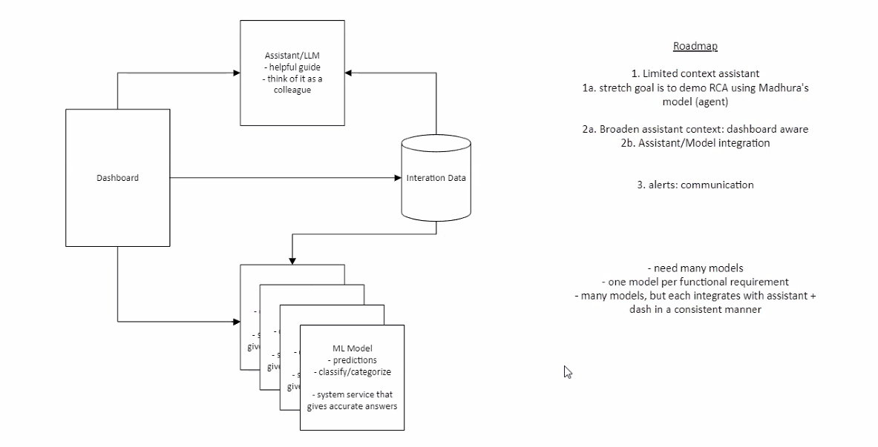

Collect user behavior data

Preprocess data

Build a machine learning model

Identify the characteristics of bad agents in particular

Identify the error encountered during the submission process

Result: Exact reason for drop-out

Collect user behavior data

Preprocess data

Build a machine learning model

Identify the characteristics of bad agents in particular

Identify the error encountered during the submission process

Result: Exact reason for drop-out